**APPENDIX 1**

# SHOPPING WEBSITE

END TERM REPORT

***by***

Botta Sai Sakthi Dwarampudi Rama Surya Konda Reddy

(Section: K19XC) (Section: K19XC)

(Roll Number: 01) (Roll Number: 02)

Saurabh Sharma Pandikunta Mohitha

(Section: K19XC) (Section: K19XC)

(Roll Number: 03) (Roll Number: 04)



**Department of Intelligent Systems**

**School of Computer Science Engineering**

**Lovely Professional University, Jalandhar**

April-2020

**APPENDIX 2**

Student Declaration

This is to declare that this report has been written by me/us. No part of the report is copied from other sources. All information included from other sources have been duly acknowledged. I/We aver that if any part of the report is found to be copied, I/we are shall take full responsibility for it.

Botta Sai Sakthi

(Roll Number: 01)

Dwarampudi Rama Surya Konda Reddy

(Roll Number: 02)

Saurabh Sharma

(Roll Number: 03)

Pandikunta Mohitha

(Roll Number: 04)

Place: Lovely professional university

Date: 10-04-2020

**APPENDIX 3**

**TABLE OF CONTENTS**

**TITLE PAGE NO.**

1. **Background and objectives of project assigned ................** **5**

**1.1 Introduction ……**............................................................ **5**

**1.1.1 Motivation…................................................................. 5**

* + 1. **Project scope ………………………………............................**  **5**
    2. **Project objectives......................................................6**

**2. Description of Project........................................................... 6**

**3. Work division among students......................................** **7**

**4. Implementation of scheduled work of project...................8**

**5. Technologies and framework to be used…………………10**

**6. SWOT Analysis achieved in project………………………11**

APPENDIX 4

BONAFIDE CERTIFICATE

Certified that this project report “………. ONLINE SHOPPING WEBSITE........” is the bonafide work of “…………..SAI SAKTHI, DWARAMPUDI SURYA KONDA REDDY, SAURABH SHARMA, PANDIKUNTA MOHITHA………” who carried out the project work under my supervision.

<<Signature of the Supervisor>>

<<Name of supervisor>>

<<Academic Designation>>

<<ID of Supervisor>>

<<Department of Supervisor>>

**1.Background and objectives of project assigned:**

1.1. INTRODUCTION:

Online shopping is the process whereby consumers directly buy goods or services from a seller in real-time, without an intermediary service, over the Internet. It is a form of electronic commerce. This project is an attempt to provide the advantages of online shopping to customers of a real shop. It helps buying the products in the shop anywhere through internet by using an android device. Thus the customer will get the service of online shopping and home delivery from his favorite shop

* The project online shopping has been developed on HTML, CSS.
* I have used HTML to create and save web document. E.g. notepad
* CSS (cascading style sheets) for web page formatting & to create attractive layout.

1.1.1 MOTIVATION:-

* This is my first internet programming course, I want to create a project which is easy but also challenging.

1.1.2 PROJECT SCOPE:

This system can be implemented to any shop in the locality or to multinational branded shops having retail outlet chains. The system recommends a facility to accept the orders 24*7 and a home delivery system which can make customers happy. If shops are providing an online portal where their customers can enjoy easy shopping from anywhere, the shops won’t be losing any more customers to the trending online shops such as ebay. Since the application is available in the Smartphone it is easily accessible and always available.

OBJECTIVES:

1.1.3.The project objectives are:

The objective of the project is to make an application in android platform to purchase items in an existing shop. In order to build such an application complete web support need to be provided. A complete and efficient web application which can provide the online shopping experience is the basic objective of the project. The web application can be implemented in the form of an android application with web view.

* To make the shopping easier and comfortable
* To create a web portal with a content management system which would allow product information to be updated securely using a mobile device.
* To serve the customers without wasting their precious time.
* To reach the products to the customer’s address with great care.

**2.Description of project:**

This project is a web based shopping system for an existing shop. The project objective is to deliver the online shopping application into android platform.

This project is an attempt to provide the advantages of online shopping to customers of a real shop. It helps buying the products in the shop anywhere through internet by using an android device. Thus the customer will get the service of online shopping and home delivery from his favorite shop. This system can be implemented to any shop in the locality or to multinational branded shops having retail outlet chains.

If shops are providing an online portal where their customers can enjoy easy shopping from anywhere, the shops won’t be losing any more customers to the trending online shops such as ebay. Since the application is available in the Smartphone it is easily accessible and always available.

**3.Description of work division in terms of roles among students:**

**Sai sakthi:-**

* Collecting information about all different types of products.
* Searching about product’s price, quality.. etc which are needed for this project.

**Surya:-**

* Creating button for login and sign up in the project.
* Collecting the various suitable tags.
* Collecting screenshots of the products which are used to show in the website.

**Saurabh:-**

* Creating the columns for information about different products.
* Creating links and font styles for given project.
* And adding some more information about required tags on terms of services.

**Mohitha:-**

* To design the whole home page with coding HTML and adding internal and inline CSS.
* Creating the browse for electronics, TV & appliances, men& women wears and more products for the given project.
* And creating link to the page with external CSS and background of document

**IMPLEMENTATION OF SCHEDULED WORK OF PROJECT**

|  |
| --- |
| VIEW PRODUCT |

|  |
| --- |
| USER |

|  |
| --- |
| SEARCH FOR PRODUCT |

|  |
| --- |
| SEARCH PRODUCT |

**➢ Registration**

A new user will have to register in the system by providing essential details in order to view the products in the system. The admin must accept a new user by unblocking him.

➢ **Login**

A user must login with his user name and password to the system after registration.

➢ **View Products**

User can view the list of products based on their names after successful login. A detailed description of a particular product with product name, products details, product image, price can be viewed by users

➢ **Search Product**

Users can search for a particular product in the list by name.

➢ **Add to cart:**

The user can add the desired product into his cart by clicking add to cart option on the product.

He can view his cart by clicking on the cart button. All products added by cart can be viewed in the cart. User can remove an item from the cart by clicking remove.

➢ Submit Cart:

After confirming the items in the cart the user can submit the cart by providing a delivery address. On successful submitting the cart will become empty.

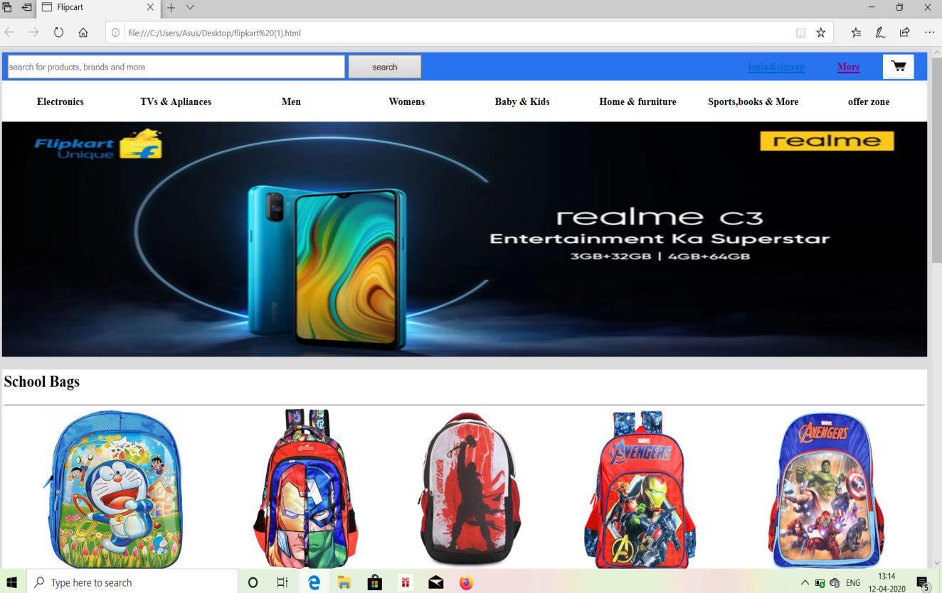

➢ USER LOGIN

Description of feature

This feature used by the user to login into system. A user must login with his user name and password to the system after registration. If they are invalid, the user not allowed to enter the system.

- Username and password will be provided after user registration is confirmed.

- Password should be hidden from others while typing it in the field

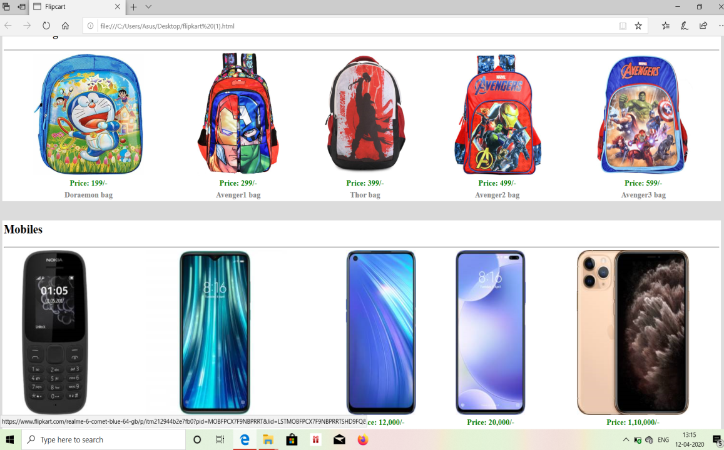

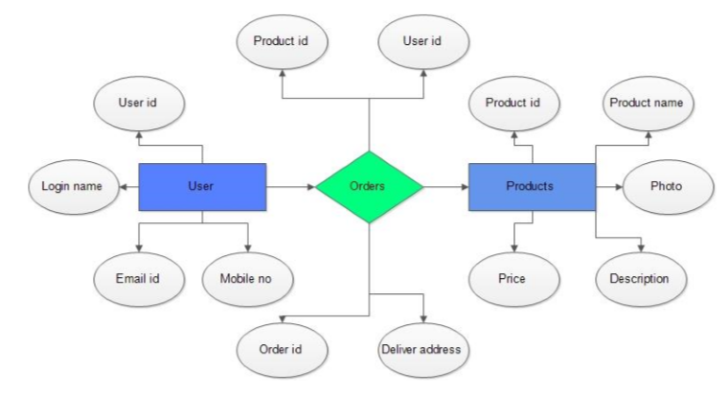

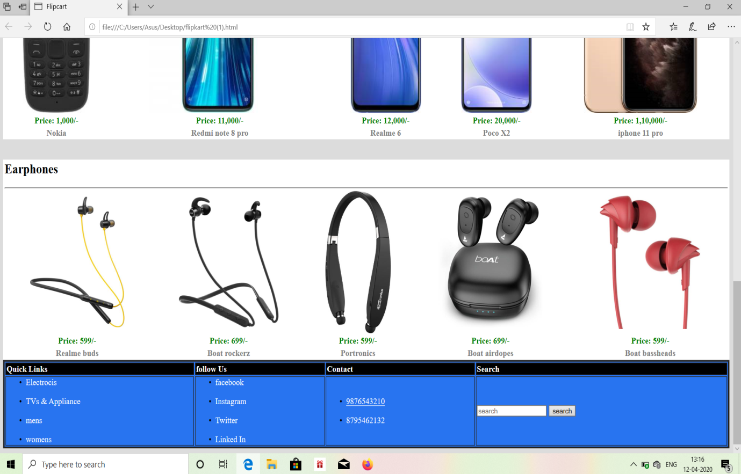

**Technologies and framework to be used:**

Technologies:- HTML and CSS.

References:

http://www.w3schools.com/html/defualt.asp,

http://www.w3schools.com/css/default.asp,

http://www.w3schools.com/js/default.asp

**SWOT Analysis achieved in project:-**

The project entitled Online shopping system was completed successfully.

The system has been developed with much care and free of errors and at the same time it is efficient and less time consuming. The purpose of this project was to develop a web application and an android application for purchasing items from a shop.

This project helped us in gaining valuable information and practical knowledge on several topics like designing web pages using html & css, usage of responsive templates, designing of android applications, and management of database using mysql . The entire system is secured. Also the project helped us understanding about the development phases of a project and software development life cycle. We learned how to test different features of a project.

This project hass given us great satisfaction in having designed an application which can be implemented to any nearby shops or branded shops selling various kinds of products by simple modifications.